PIZZA SALES SQL QUERIES

1. KPI’s
2. Total Revenue:

Select SUM(total_price) as Total_Revenue

From pizza_sales

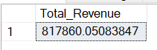

1. Average Order Value:

Select SUM(total_price) / COUNT(DISTINCT(order_id)) as Avg_order_value

from pizza_sales



1. Total Pizzas Sold

Select SUM(quantity) as Total_pizza_sold

from pizza_sales

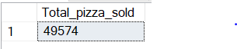

1. Total Orders

Select COUNT(DISTINCT(order_id)) as Total_orders

from pizza_sales



1. Average Pizzas Per Order

Select CAST(SUM(quantity) as DECIMAL(10,2)) /

CAST(COUNT(DISTINCT(order_id)) AS DECIMAL(10,2)) as Avg_pizza_per_order

from pizza_sales



1. CHARTS
2. Daily Trend for total orders

Select DATENAME(DW,order_date) as order_day, COUNT(DISTINCT(order_id)) as orders

From pizza_sales

Group by DATENAME(DW,order_date)

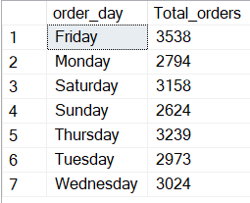

1. Monthly Trend for Total orders

Select DATENAME(MONTH,order_date) as order_month, COUNT(DISTINCT(order_id)) as

From pizza_sales

Group by DATENAME(MONTH,order_date)

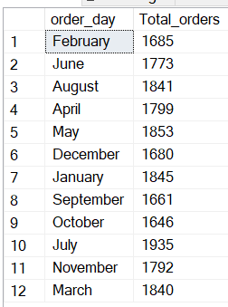

1. Percentage of sales by pizza size

SELECT pizza_size,SUM(total_price) as total_sales, SUM(total_price) * 100 /

(SELECT SUM(total_price) FROM pizza_sales) as Pizza_pct

WHERE DATEPART(Quarter,order_date) = 1 –-For First Quarter i.e (Jan – April)

FROM pizza_sales

Group by pizza_size

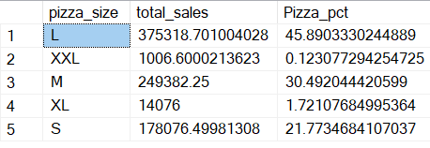

1. Percentage of sales by pizza category

SELECT pizza_size,SUM(total_price) as total_sales, SUM(total_price) * 100 /

(SELECT SUM(total_price) FROM pizza_sales) as Pizza_pct

FROM pizza_sales

Group by pizza_size

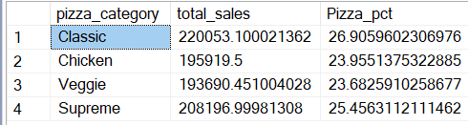

1. Total Pizzas Sold by Pizza Category

SELECT pizza_category, SUM(quantity) as Total_pizzas_sold

FROM pizza_sales

Group by pizza_category

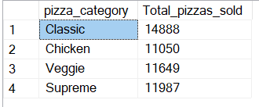

1. Top 5 Best Sellers by Revenue, Total Quantity and Total Orders

-- By Revenue

SELECT TOP 5 pizza_name, SUM(total_price) as Total_reve

FROM pizza_sales

Group by pizza_name

Order by Total_revenue desc

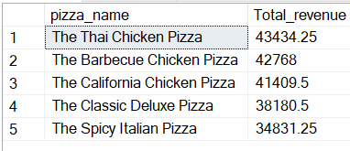

--By Total Quantity

SELECT TOP 5 pizza_name, SUM(quantity) as Total_quantity

FROM pizza_sales

Group by pizza_name

Order by Total_quantity desc

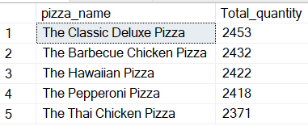

-- By Total Orders

SELECT TOP 5 pizza_name, COUNT(DISTINCT order_id) as Total_orders

FROM pizza_sales

Group by pizza_name

Order by Total_orders desc

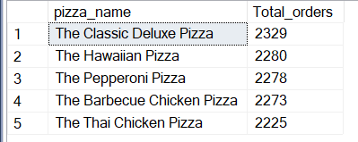

1. Top Worst Sellers by Revenue, Total Quantity and Total Orders

--By Revenue

SELECT TOP 5 pizza_name, SUM(total_price) as Total_revenue

FROM pizza_sales

Group by pizza_name

Order by Total_revenue

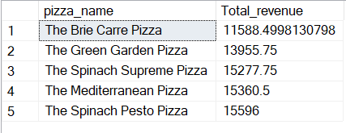

--By Total Quantity

SELECT TOP 5 pizza_name, SUM(quantity) as Total_quantity

FROM pizza_sales

Group by pizza_name

Order by Total_quantity

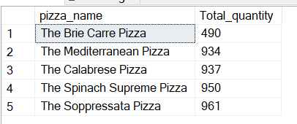

--By Total Orders

SELECT TOP 5 pizza_name, COUNT(DISTINCT order_id) as Total_orders

FROM pizza_sales

Group by pizza_name

Order by Total_orders

